6 out 176 participants finish less than 7 credits. Why?

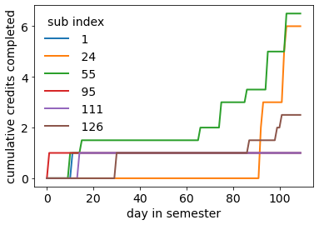

1 I spread out my hours throughout the semester, doing half earlier on and half in the last two weeks.

2 I did studies throughout the semester and completed it all at the end. I signed for studies some weeks and didn't for others.

5 I just set a reminder in my phone

1 I thought that the studies wouldn't take as long as they did, so I pushed some of them them off for later.

2 I was struggling with my mental and emotional health throughout the semester so I only sat and did the studies when I had the drive to

5 I had alot of problems at home that affected my ability to do well in school

0 I dropped out of the class so I only did hours at the beginning of the semester

3 As I withdrew from the class, I did not fulfill the requirement.

4 Allocated most hours towards the end of the semester.

0 Forgetting that we have to do it

3 As I withdrew from the class, I did not fulfill the requirement.

4 Life circumstances. Balancing school work, work, and providing support for sick family members.

Clustering the completion patterns of the rest of the participants (normalized progress)

0 1

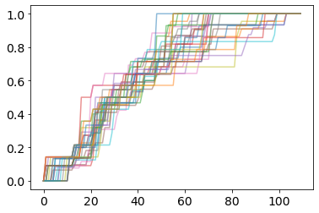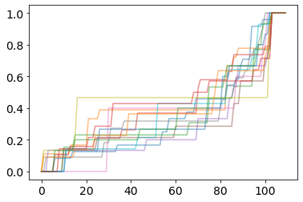

2 3

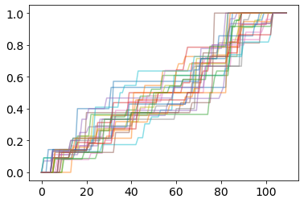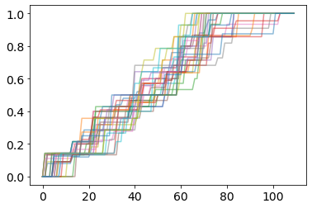

4 5

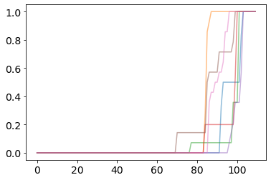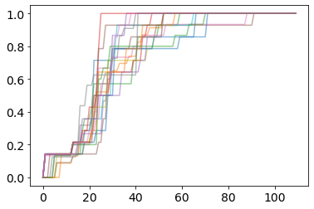

6 7

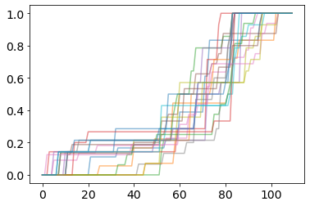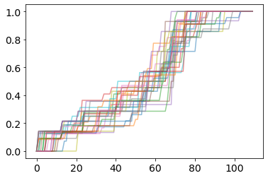

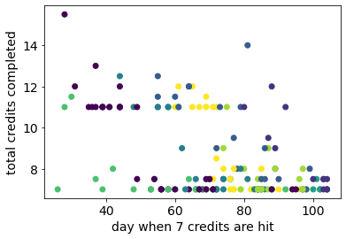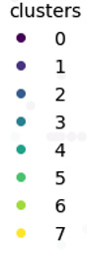

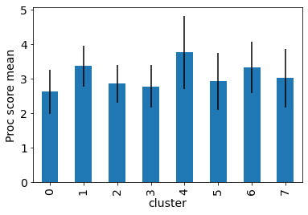 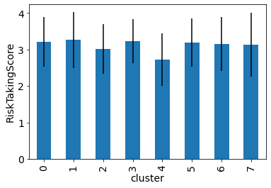

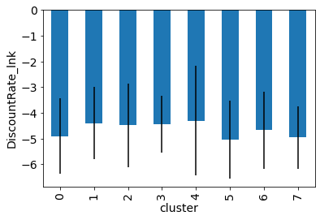 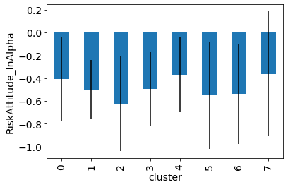

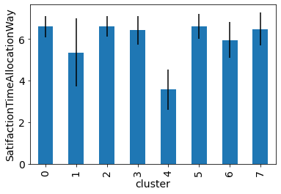

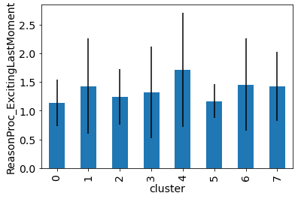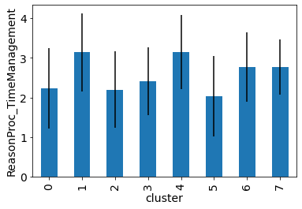

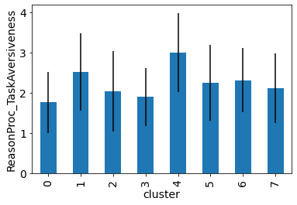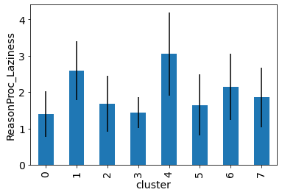

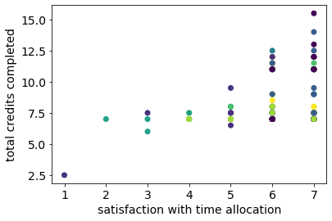 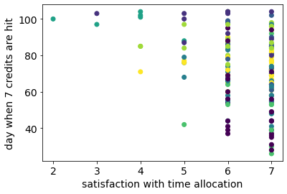

Cluster 0  
  
Allocation:

* **Early Semester Focus:**
  + Most students completed the bulk of their hours early in the semester to avoid last-minute stress.
  + Emphasis on finishing research requirements and participation in the initial weeks.
* **Regular Monitoring and Quick Response:**
  + Active monitoring of platforms like the Sona website for immediate sign-ups.
  + Some checked daily, while others set aside specific times each week.
* **Varied Approaches:**
  + Diverse strategies, including completing all hours early or spreading them out evenly.
  + Some prioritized required credits early, occasionally taking on extra credit studies.
* **Time Management:**
  + Dedicated times each week or weekends for research participation.
  + Strategic planning considering workload and availability throughout the semester.
* **Preemptive Planning:**
  + Proactive approach anticipating busier periods later in the semester.
  + Planning ahead, such as scheduling weekly study sessions or allocating specific times.
* **Adaptability and Flexibility:**
  + Flexibility in participation based on study lengths, availability, and personal preferences.
  + Fluctuating weekly commitments, maintaining an average time commitment per week.
* **Consideration of Future Opportunities:**
  + Anticipation of reduced opportunities later in the semester led to early sign-ups.
  + Seizing extra credit opportunities, particularly those with shorter durations.
* **Steady Progress and Early Completion:**
  + Emphasis on early engagement to alleviate stress during exams or midterms.
  + Majority completed most required hours in the initial weeks or months.

Procrastination reasons

* Fear of not meeting the deadline
* Anticipation of end-of-year rush motivated early completion, other semester commitments
* Determination to achieve academic goals
* Desire and planning to minimize stress rest of semester, avoid last minute stress/ struggles
* Goal to prevent forgetting credits later on
* Collaborative work with a friend as a deterrent to procrastination
* Use of research as a productive form of procrastination
* Enjoyment of in-person aspect and finding the studies fun
* Allocation of time in case of unexpected issues, decrease in available studies later
* Desire to finish the requirement as soon as possible
* Avoidance of hindrance to passing the class
* Dislike of procrastination due to stress and subpar work
* Desire to eliminate the looming deadline for better mental health
* Diligent effort to stay ahead and finish early with the help of reminders

Cluster 1:

Allocation:

* Completed study requirements gradually, allocating more towards extra credit at the end.
* Online studies were done throughout the semester, sometimes in multiple sittings.
* Some signed up for studies intermittently throughout the semester.
* Studies were completed at night or during breaks from regular homework.
* Initial effort to fulfill 2 hours in the first two weeks, followed by gradual completion.
* Set a phone reminder for tracking and managing study participation.
* Split research hours, completing half at the beginning and the rest at the end.
* Early semester focus to minimize workload during midterm season and the end.
* Majority of hours fulfilled at the beginning of the semester, with additional studies near the end for contingency.

Procrastination reasons:

* Some studies were time-consuming and boring, especially repetitive tasks.
* fatigue, and distant deadline/ due dates
* laziness, distractions
* Free time was intentionally used for research to avoid future concerns.
* Mental health struggles led to completing studies only when motivated.
* Home problems impacted academic performance and study completion.
* ADHD influenced the need for imminent deadlines for motivation.
* Busyness, other earlier deadlines and other commitments, and easyness of studies
* Being in a different time zone (Taiwan) for the first two months affected time management.
* Lack of suitable technology delayed starting certain studies.

Cluster 2:  
  
Allocation:  
.

* Weekly checks on the Sona system facilitated even distribution.
* Free time, weekends, and Friday nights, regular completion strategy
* Some evenly distributed hours throughout the semester
* Some students completed all hours early, while others prioritized weekly participation.
* Flexibility was maintained by checking due dates and adapting to workload.
* Phased approaches included finishing the first half early or spreading credits across the semester.
* Proactive early completion was highlighted, with an awareness of diminishing opportunities over time.

Procrastination reasons:

* Initial effort but later forgot about the requirement.
* Ensured credits early in case of study availability issues.
* Completed surveys when bored, finding them enjoyable.
* Weekly system checks, effective allocation
* Time-consuming, desire for free time, lack of interest.
* Unprecedented plans
* Accountability
* Fear of incomplete grade, urgency to complete on time.
* Perceived simplicity and assurance of completion.
* No last-minute worries, reduced end-of-semester stress.
* Second-half challenges with graduation and thesis.
* Balancing school work and workload considerations.
* Extra credit motivation during procrastination.
* Negative experience with a boring survey

Cluster 3:

Allocation:

* Adjusted schedule due to different time zone.
* Started early with a goal to achieve extra credit.
* Spread hours throughout the semester.
* Completed most hours in the first half of the semester.
* Consistent weekly commitment, sometimes on weekends for early completion
* Completed hours as soon as new studies opened.
* Started early to ensure availability of studies.
* Completed as early as possible to avoid scheduling issues.
* Utilized free time, breaks to finish surveys progressively.
* Dedicated a day towards the end to finish the requirement.
* Finished the initial 7 hours early, waited for interesting studies.
* Early fulfillment
* Participated in surveys during breaks between classes.

procrastination reasons

* Managed time due to demanding classes.
* Juggling multiple commitments, Home commitments and workload influenced schedule.
* Prioritized early fulfillment due to limited time later, avoid stress and crammin in the end
* Lower priority than other assignments and exams.
* Difficulty remembering studies, limited interesting options.
* Relied on a calendar app for timely reminders.
* Interest in psychology and desire for extra credit.
* Fear of failure and desire not to miss requirements/ good grade
* personal issues, and anxiety.
* Eagerness to fulfill requirement for peace of mind.
* Appreciation for the predictability of research tasks.
* Fitting into schedule as a productive break.
* Organized, scheduled, and efficient time management.
* Past trouble with procrastination, avoiding repeats; consciously avoid procrastination

Cluster 4:

Allocation:

* Distributed hours: Half early, half in the last two weeks.
* Completed most hours late in the semester.
* Predominantly late in the semester due to early issues.

Procrastination:

* Underestimated study duration, leading to postponement.
* forgetfulness due to class and external pressures.
* Struggled to find time, resulting in burnout during extended sittings.
* Admitted laziness and preference for completing all at once.
* ADHD diagnosis contributing to procrastination.
* Personal loss affecting ability to focus and engage.

Cluster 5

Allocation:

* Initiated research participation early, with a break, then completed the last hours later.
* Front-loaded studies in the beginning to manage workload during heavier periods, avoiding stress
* Aimed for weekly credit fulfillment to finish the requirement early in the semester.
* Completed research as early and frequently as possible to expedite the process, get out way
* Actively sought and scheduled studies early on to fulfill the requirement.
* Completed most hours during weekends with free time.
* Primarily engaged in research participation during mid to late hours of the day.

Procrastination reasons

* Distractions such as video games, social media, and social activities.
* Heavy credit load prompted early completion due to anticipated time constraints, busier periods
* Concerns about passing the class, maintaining grade
* Ensuring the availability of studies
* Desire to quickly finish and obtain extra credit
* reducing midterm/finals stress.
* Recognition of lower busyness early in the semester for timely fulfillment.
* Perception of research as tedious influenced motivation.
* Other assignments or personal mindset

Cluster 6

Allocation:

* Primarily did hours early in the semester, attempting to distribute them evenly.
* Averaged about one survey per week, or weekends.
* Utilized a week with minimal workload to fulfill most hours within two days.
* Completed the majority of hours in the middle of the semester when free, in march-april
* Allocated 30 minutes to 1 hour every weekend to complete tasks.
* Worked on hours early when free, avoiding very early or very late completion.
* Started allocating time seriously around halfway through the semester, finishing with a 0.25 bonus before finals week.
* Aimed to complete hours as early as possible, finishing with about a month left in the semester.
* Engaged in studies whenever bored and aimed for productivity.
* Completed a few studies early in the semester and a few more towards the end.
* Majority of the studies were done in the mid to end of the semester.

procrastination:

* Procrastinated on the research requirement, considering it manageable and fast.
* Tendency to prioritize difficult tasks over easy ones, other imminent due dates
* Avoided last-minute stress by signing up for studies throughout the semester.
* Opted for leisure activities like watching YouTube instead of participating in studies.
* Deadline seemed distant, resulting in occasional delays in research participation.
* Secured extra studies to avoid uncertainty and ensure additional credit.
* Fatigue from classwork in other subjects
* Desire to complete the requirement early to eliminate stress later in the semester.
* Initiated research participation about halfway through the semester.
* Temporary lapse in remembering to fulfill the hours during the middle of the semester.
* Boredom and a desire to fulfill the requirement before the semester's end.
* laziness and lack of awareness.
* Lack of prioritization due to a belief in having made sufficient progress on credit hours.

Cluster 7

Allocation:

* Responded promptly to new study emails, completing them on the spot to accumulate hours quickly.
* Allocated time at night, free time for compatible research.
* Checked the research website every weekend
* Distributed time evenly throughout the semeste.
* Completed most hours early in the semester.
* Gradually completed hours through the semester, focusing on the early part to alleviate later stress.
* No specific method, signed up for studies of interest and completed them before expiration, trying to earn extra credit by doing at least one study a week.
* Did half at the beginning of the semester and the rest when sick later in the year.
* Started research early to seize good opportunities and had the flexibility to choose interesting studies.
* Attempted to fit in as many hours as possible early on for both the requirement and extra credit, doing a few studies a week from the start.
* Tried to complete many hours early in the semester but finished around midway due to getting busy with other schoolwork.

Procrastination:

* Prefers not to wait until the last second and tries to finish work proactively.
* Tired or exhausted, lack of motivation, boring, distractions
* Finished all available studies, leaving nothing to do for a block of time.
* Enjoyed some research projects, making them more tolerable.
* Cited mental health issues as a reason.
* Other commitments, such as busy weeks with deadlines and tests from other classes.
* Procrastinated a little, prioritizing more time-sensitive schoolwork.
* Set a commitment to do at least an hour of studies over the weekend, with a friend's reminder.
* Desire to get it over with.
* Procrastinated due to other priorities or wanting to pass the time, also motivated by extra credit.
* Stress from other classes as a contributing factor.
* Considered the task not difficult with a good cost/benefit ratio.
* Used calendar reminders after missing a study, helping with completion.
* Procrastinated on signing up for studies, sometimes due to not feeling like doing them immediately and experiencing burnout from other work.
* waiting until the last minute to get work done, acknowledging it as a bad habit.